Ideation Phase
Empathize & Discover
Date | 12 October 2026
Team ID | SWUID2026403111
Project Name | IMovies – Online Movie, Event & Entertainment Ticket Booking System
Maximum Marks | 4 Marks
Empathy Map Canvas:
Persona 1 – Customer (Movie / Event Goer)
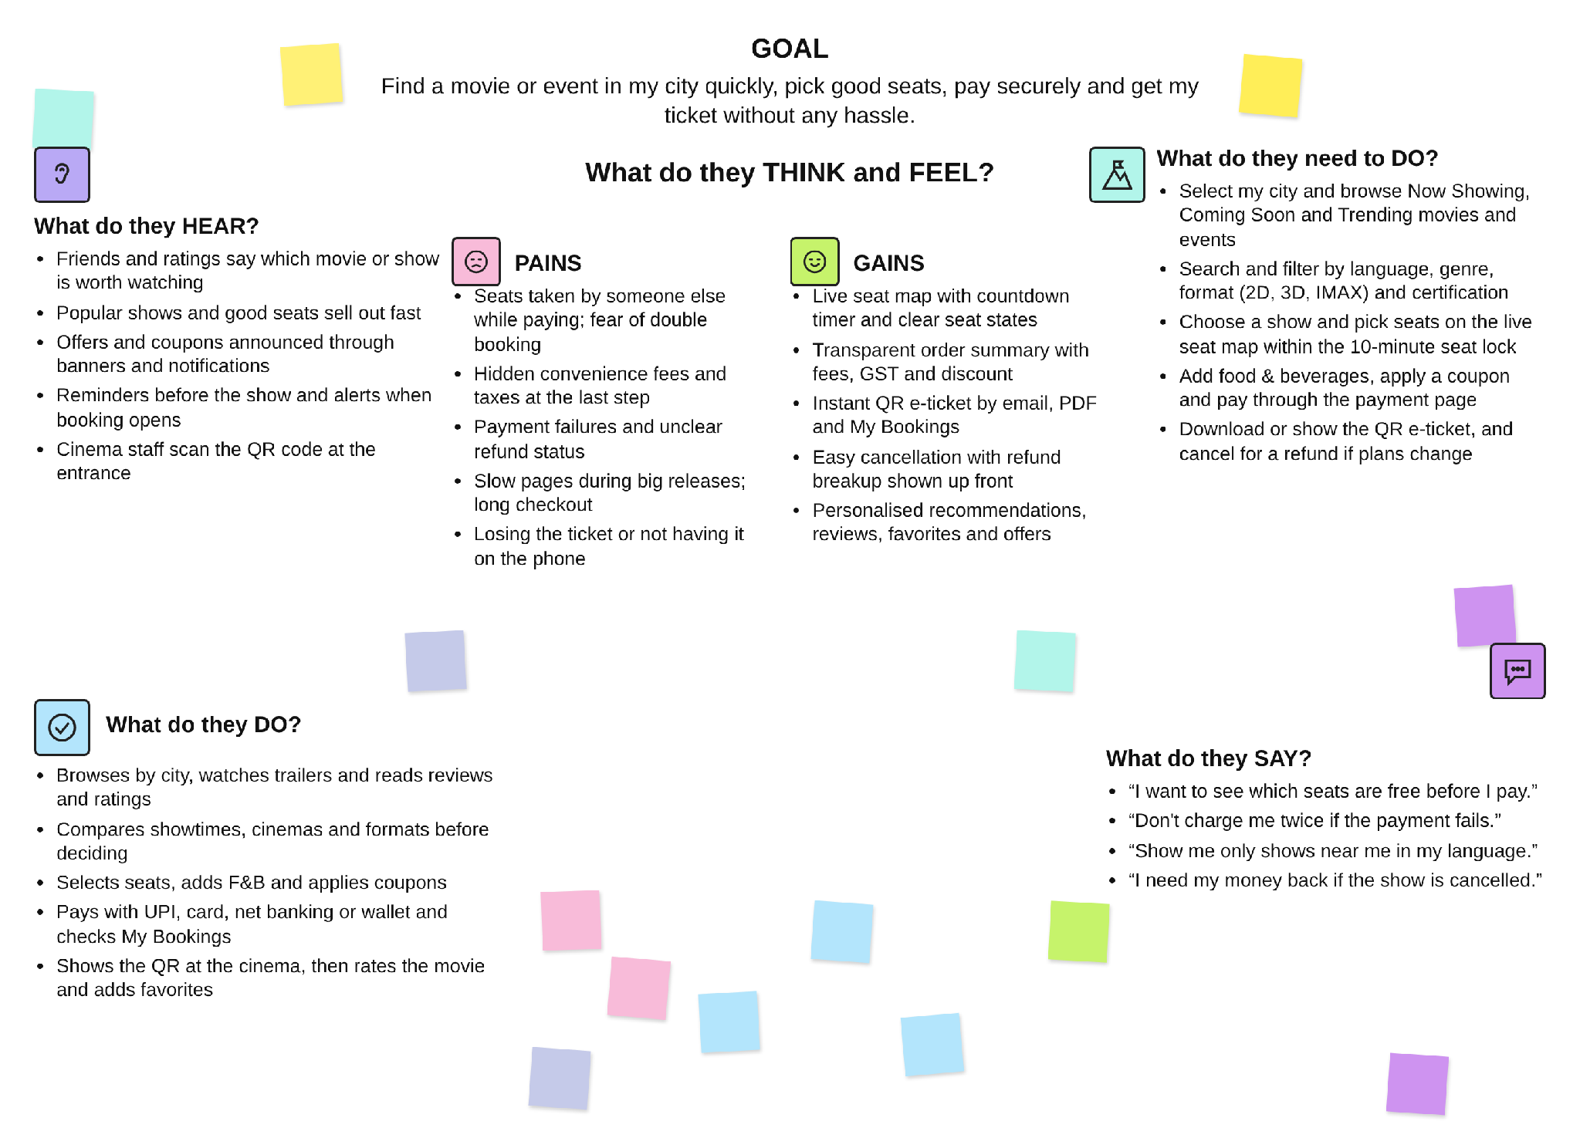
Persona 2 – Cinema Manager / Event Organizer / Admin
Understand the needs of the people who run cinemas and events and manage the platform behind the scenes.
